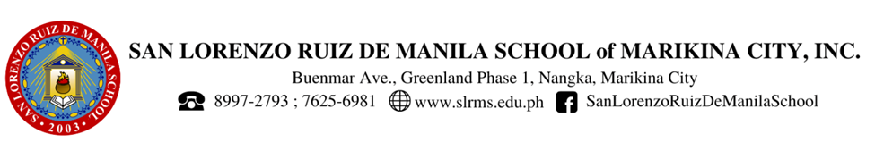

**SAN LORENZO RUIZ DE MANILA SCHOOL, INC. REFLECTION 2024**

San Lorenzo Ruiz de Manila School, the younger and smaller institution founded by Mrs. Lydia Cuevas-Vicente, proudly follows the legacy of its elder counterpart, Lorenzo Ruiz de Manila School, Inc. Both schools are united by the founder’s vision of nurturing God-loving leaders who will one day guide the nation. San Lorenzo Ruiz de Manila School is dedicated to instilling values of faith, leadership, and service in its students, ensuring they are well-prepared to make meaningful contributions to society. Through a holistic education that emphasizes moral and spiritual growth, the school aims to develop future leaders who are not only academically competent but also deeply committed to the welfare of their communities and the country.

**Vision:**

A Ruizian Catholic educational institution of servant leaders

    who live faith, hope, and love in communion

significantly contributing to national and world progress, unity, and peace.

**Mission:**

As an educational community distinctly LAY, CATHOLIC, and FILIPINO,

SLRMS is committed to:

* work toward the holistic formation of servant leaders who are centered on the Eucharist, modeled on the Blessed Virgin Mary and St. Lorenzo Ruiz and so become witnesses of the Gospel;
* continuously strive for transformative education that is innovative, dynamic and globally responsive; and
* efficiently manage resources for viability and sustainability.

**Core Values: COMMUNION, SERVICE, EXCELLENCE**

The Core Values of San Lorenzo Ruiz de Manila School of Marikina, Inc. stem from the philosophy, vision and mission of the school as exemplified by its patron saint, St. Lorenzo Ruiz.

Like Lorenzo Ruiz de Manila School, San Lorenzo Ruiz de Manila School (SLRMS) aspires to contribute to making the world a better place to live in. Reflecting on the very palpable effect of climate change in our environment, we cannot help but have this burning desire in our hearts that we cannot just be bystanders. We need to act for time is running short. As they say, we are on the 11th hour.

In recent years, we have seen and felt how the Earth has been experiencing unprecedented levels of environmental degradation, seen in climate change, deforestation, loss of biodiversity, and pollution. These issues are not just scientific or economic concerns but deeply moral and spiritual crises. [Pope Francis, in his encyclical *Laudato Si’*, calls for a deep reflection on our relationship with nature, urging us to recognize the Earth as our common home, a sister who cries out because of the harm inflicted upon her by our irresponsible actions1](https://www.vatican.va/content/francesco/en/encyclicals/documents/papa-francesco_20150524_enciclica-laudato-si.html). This call echoes our school’s core values of communion, service, and excellence, guiding us to respond with compassion, action, and a commitment to the highest standards of stewardship.

**Communion** emphasizes the interconnectedness of all creation. [Pope Francis reminds us that everything is interconnected, and the health of our planet is intrinsically linked to the well-being of humanity](https://www.vatican.va/content/francesco/en/encyclicals/documents/papa-francesco_20150524_enciclica-laudato-si.html)[2](https://www.laudatosi.org/the-letter/). As a community, we are called to promote a sense of solidarity with the Earth and all its inhabitants. [This means recognizing that environmental degradation disproportionately affects the poor and vulnerable, who often bear the brunt of climate change and pollution](https://www.vatican.va/content/francesco/en/encyclicals/documents/papa-francesco_20150524_enciclica-laudato-si.html)[3](https://en.wikipedia.org/wiki/Laudato_si%27). By embracing communion, we commit to standing in solidarity with those who suffer most from environmental harm, advocating for policies and practices that promote environmental justice and protect the dignity of every person.

**Service** is at the heart of our response to environmental challenges. [Pope Francis urges us to take concrete actions to care for our common home, emphasizing that small daily gestures can contribute to a larger transformation4](https://www.americamagazine.org/issue/laudato-si-joins-tradition-catholic-social-teaching). This involves reducing our carbon footprint, conserving resources, and promoting sustainable practices in our communities. Service also means educating ourselves and others about the importance of environmental stewardship, inspiring a culture of care and responsibility. By integrating service into our lives, we become active participants in the healing of our planet, embodying the spirit of *Laudato Si’* through our actions.

**Excellence** calls us to strive for the highest standards in all that we do, including our efforts to protect the environment. [Pope Francis challenges us to pursue an integral ecology, which considers the complex interplay between environmental, economic, social, and cultural factors5](https://www.ewtn.com/catholicism/library/summary-of-laudato-si-3173). This holistic approach requires innovative solutions and a commitment to continuous improvement. Excellence in environmental stewardship means not only addressing the symptoms of degradation but also tackling its root causes, such as consumerism and unsustainable development. By aiming for excellence, we set a powerful example for others to follow, demonstrating that it is possible to achieve a harmonious balance between human progress and the health of our planet.

The principles of *Laudato Si’* provide a serious framework for reflecting on and responding to the environmental crises we face today. By aligning our school’s core values of communion, service, and excellence with Pope Francis’ call to care for our common home, we can make meaningful contributions to the protection and restoration of the Earth. We call on each other than to embrace this challenge with hope and determination, knowing that our collective efforts can lead to a more just and sustainable world for future generations.

Like its big sister, LRMS, SLRMS echoes its commitment to this journey - *By enrolling in the Laudato Si Action Platform this year and be part of the 7-year journey (and beyond), we are manifesting our sincere act of commitment to God, to Mother Earth, and to each other through our vigorous pursuit of responsible environmental stewardship.*

**Laudato Si!**